August 2020 TRS Reporting

- Process all August payrolls.

- Run the RP Extraction with Child Nutrition figures (if applicable) and interface to Finance. This will allow to process and interface the TRS On- Behalf journal and continue with end of year processing in Finance—BE SURE THAT YOU SAVE OFF ALL EXTRACT REPORTS FOR USE IN VERIFYING LATER; SAVE IN A FOLDER NAMED ‘PRELIMINARY AUG TRS TRS REPORTS’.

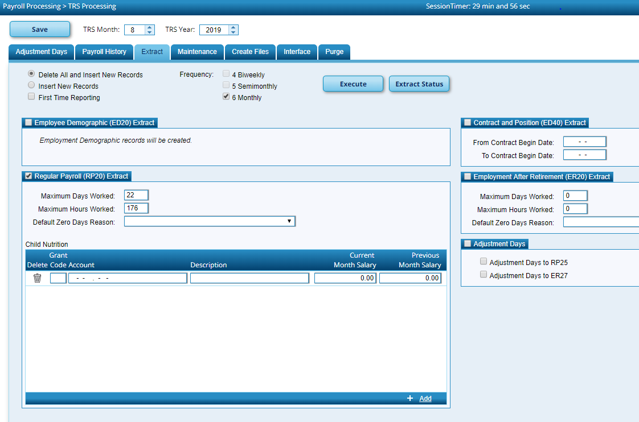
Enter Child Nutrition information if applicable for your district.

Interface to Finance using Payroll Processing>TRS Processing>Interface Tab. You may need to click on the ‘Refresh’ button for the journal voucher to populate.
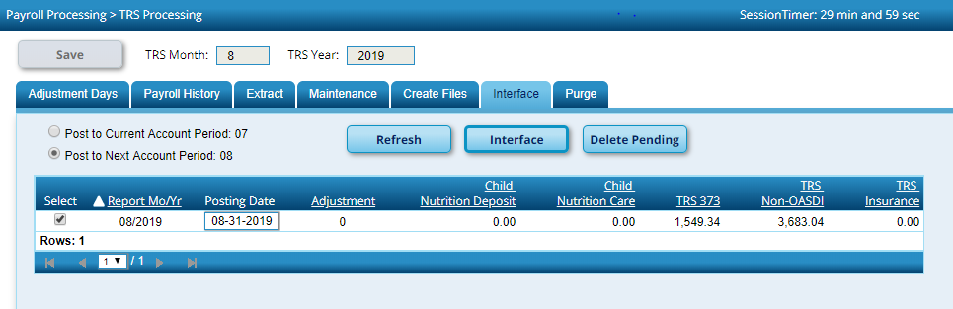

- DO NOT REPORT OR SUBMIT ANY RECORDS TO TRS AT THIS TIME!!

- If you are a district that uses TxEIS for EOY Accruals, and have not completed this process yet, run this process at this time. Refer to the EOY Payroll Process checklist for information regarding this process. After running the EOY Accruals process and interfacing to Finance, be mindful that no changes should be made to the employee’s master job and distribution records until the August Accruals are posted to payroll history as part of the end of year process (First Payroll of the School Year Checklist). If your district does not accrue through the payroll system, skip this step.

- Change to the Next Year frequency. If you have employees who start work on or
after September 1, run a user created report in Next Year payroll to identify September start date employees; then temporarily inactivate these employees in the Next Year payroll file. It is recommended to utilize the Sort/Filter functionality to sort contract begin dates in descending order for easier identification. Additionally, verify June 2020 and July 2020 PAYOFFS are inactive.
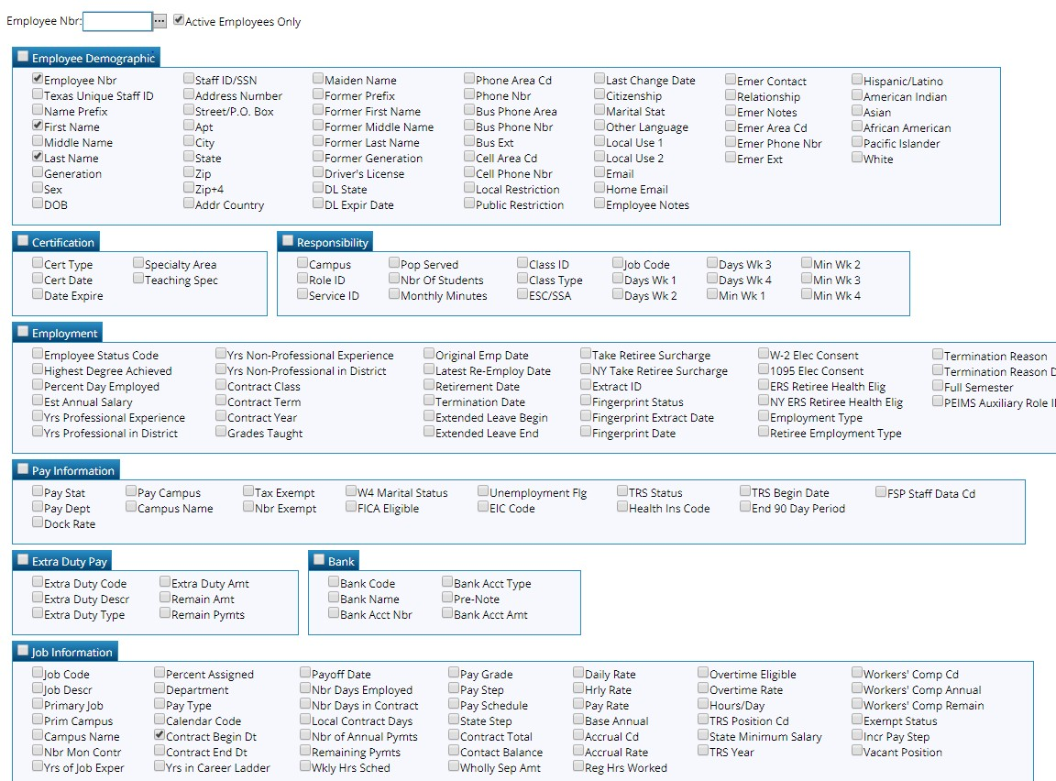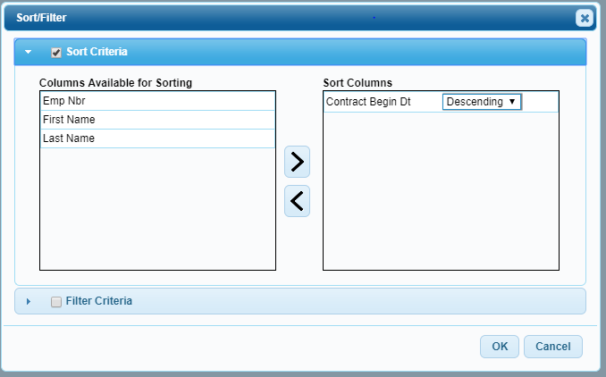

Users can easily update the Pay Status information using Utilities>Mass Update. Verify you are in the Next Year Payroll frequency. Under the Parameters, select the contract begin date(s) that need updating, execute and verify reports before processing. It is highly recommended to do an export before this is processed. Keep this information, as it will be used to activate these employees for copying over in September. In addition, you can inactive the June and July payoffs by utilizing this Mass Update screen.
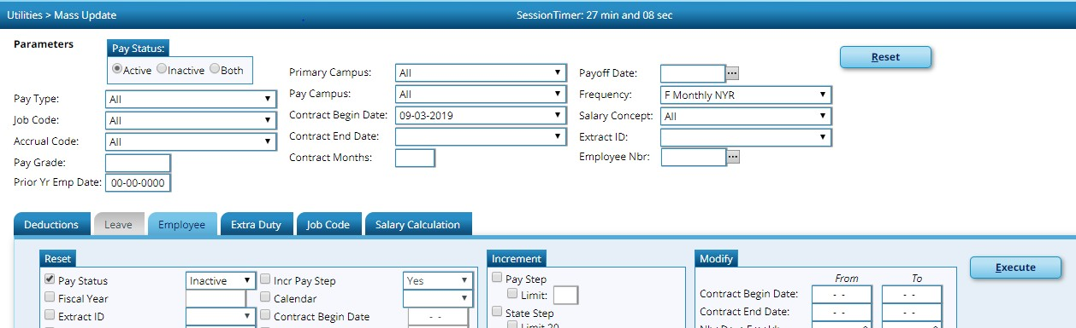

- Copy calendars - do not copy the TR calendar or any calendar that begins in September. Verify all applicable calendars copied over to current year payroll (look at process report). If not, you may have to copy over individually.
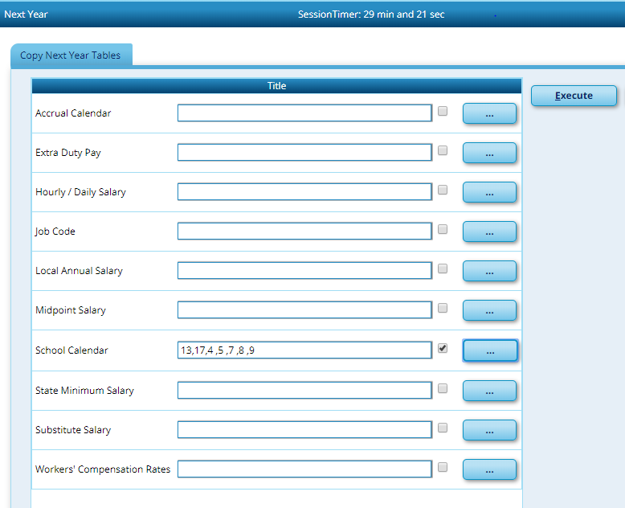

- Next, copy employees who have August contract Begin Dates from Next Year to Current Year payroll. Verify these employees have a Pay Status of ‘Active’. This process may need to be completed several times, as there may be several different August contract begin dates. Verify reports before processing. An export is recommended.
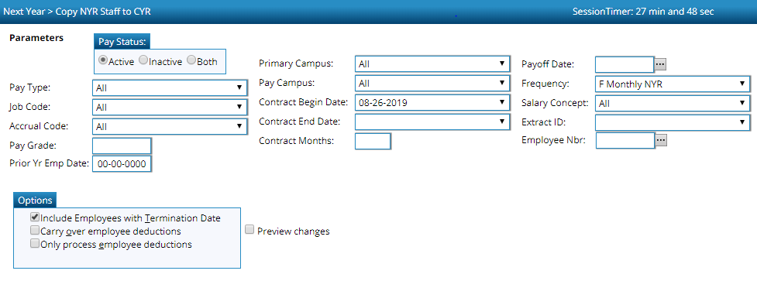

- Change to Current Payroll frequency. Payroll Processing>TRS Processing>Extract Tab. Extract the ED20 record.
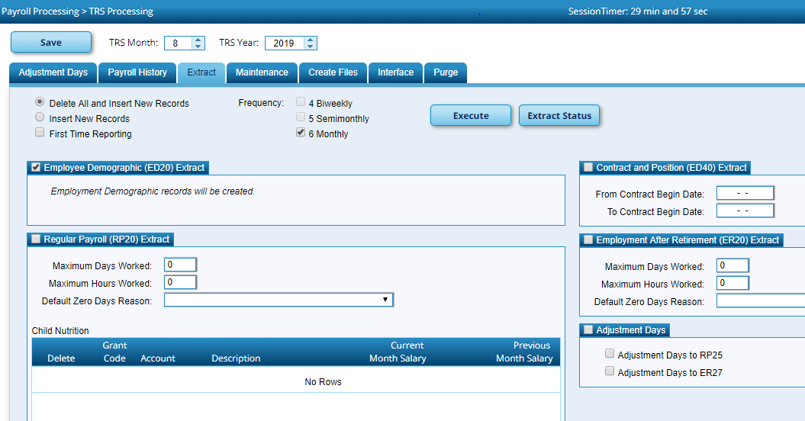

- Extract the ED40 record (use 8/1/2020 to 8/31/2020 dates). Use Reports>TRS Reports>Employee Data (ED) reports to verify ED20 and ED40 information extracted.

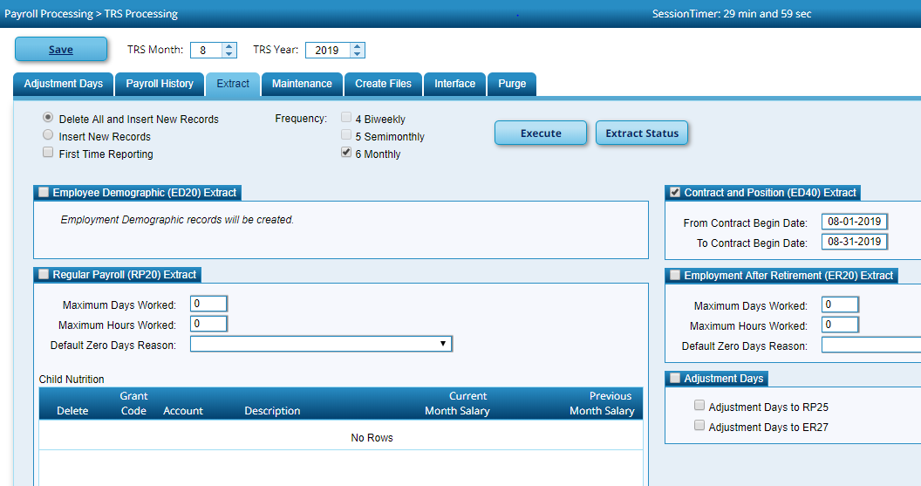
- Run the RP20 extraction again. This particular extract will not be interfaced to finance; remember - this was interfaced as part of Step 2.
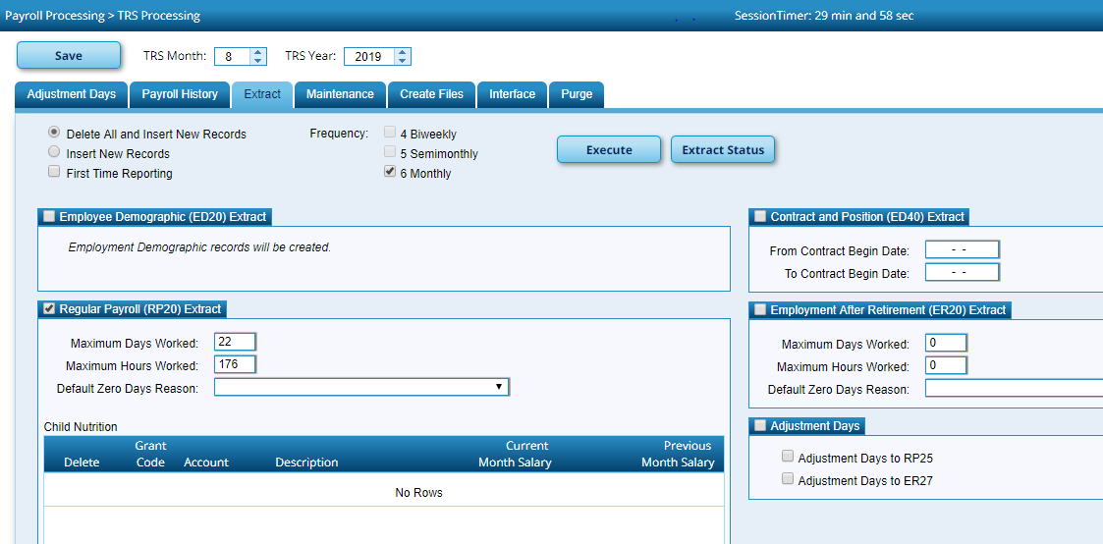

- Create the ED Submission file and upload into TRS TRS and wait for it to complete.
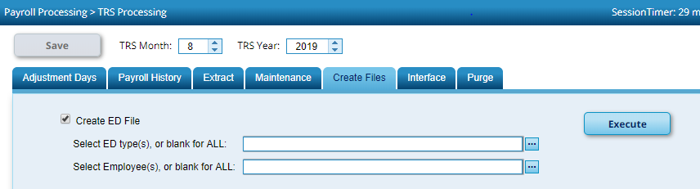

- While you are waiting on ED File to complete, manually add to the RP20 record all of the new hires for August. Utilities>TRS Submission>Data Maintenance>Regular Payroll (RP) - Add a new line, type in the name or employee number and select the desired employee; tab until the name appears. Fill in the Hours Scheduled and Days Worked for the employee and then save.
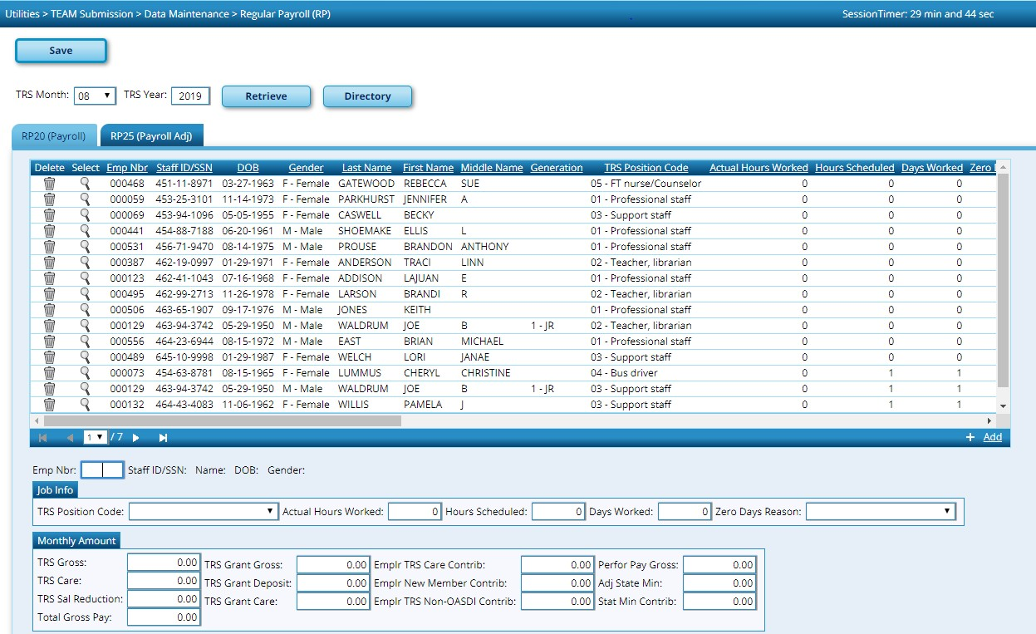

In addition, suggested maintenance on this screen is to sort by “Days Worked” to determine which employees have zero days worked for August. Insure that if an employee actually has zero days worked in August, there is a Zero Days Reason listed. If employee actually worked in August, adjust the Hours Scheduled and Days Worked fields accordingly.

- After the ED Submission is in a Completed status, create the RP Submission file and upload into TRS TRS.
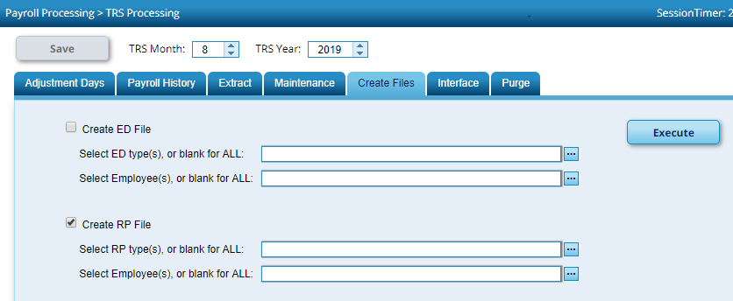

- Once everything has reached a complete status, determine what is needed to pay for TRS reporting and pay through TEXNET.

- Record what was actually paid for TRS TRS by utilizing Transfer Transaction Processing in TxEIS.

- Delete Pending TRS Interface for August.
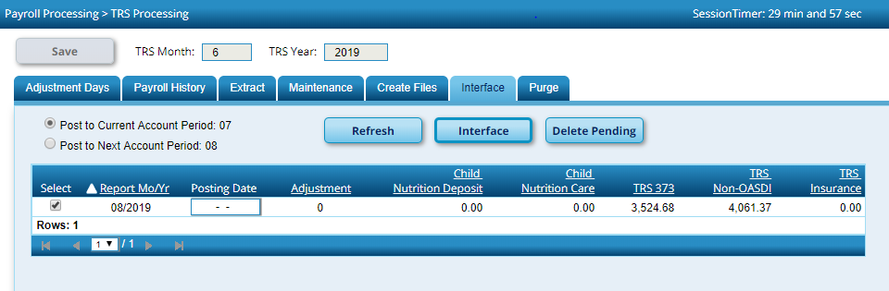

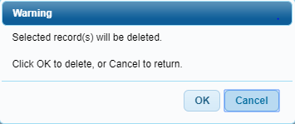
- Change to Next Year Payroll frequency. Utilities>Mass Update>Employee Tab to update the Pay Status from Inactive to Active for those employees who start work on or after September 1, 2020. Under the Parameters, select the contract begin date(s) that need updating, execute and verify reports before processing. These employees’ new contract information will be copied to current year payroll as part of the First Payroll of the School Year process.

